**Assignment 8: Social Network Analysis**

Team: Venkatesh Duvvuri ([VED14@pitt.edu](mailto:VED14@pitt.edu)); Haifa Alnasser ([HIA11@pitt.edu](mailto:HIA11@pitt.edu)); Gopi Tata ([GKT3@pitt.edu](mailto:GKT3@pitt.edu))

1. Apply the HITS algorithm to the following network.

Root Set R={1,2,3,4}

Extend it to form the base set S



The Adjacency Matrix is

A(ij)= 1 if eij subset S

0 if eij otherwise

Adjacency matrix (A) =

A<-matrix(c(0, 0, 0, 0, 1, 0, 0, 0, 0, 0, 0, 0, 0, 0, 0,

+ 1, 0, 0, 0, 1, 1, 0, 0, 0, 1, 0, 0, 0, 0, 0,

+ 0, 0, 0, 0, 0, 0, 0, 0, 0, 0, 0, 0, 0, 0, 0,

+ 0, 0, 0, 0, 0, 0, 1, 1, 1, 0, 0, 0, 0, 0, 0,

+ 0, 0, 0, 0, 0, 0, 0, 1, 0, 0, 0, 0, 0, 0, 0,

+ 1, 1, 0, 0, 0, 0, 1, 0, 0, 0, 0, 0, 0, 0, 0,

+ 0, 0, 1, 0, 0, 0, 0, 0, 0, 0, 0, 0, 0, 0, 0,

+ 0, 0, 0, 0, 0, 0, 0, 0, 0, 0, 0, 0, 0, 0, 0,

+ 0, 0, 0, 0, 0, 0, 0, 0, 0, 0, 0, 0, 0, 0, 0,

+ 0, 0, 0, 0, 0, 0, 0, 0, 0, 0, 0, 0, 0, 0, 0,

+ 0, 1, 0, 0, 0, 0, 0, 0, 0, 0, 0, 0, 0, 0, 0,

+ 1, 0, 0, 0, 0, 0, 0, 0, 0, 1, 0, 0, 1, 0, 0,

+ 0, 0, 1, 0, 0, 0, 0, 0, 0, 0, 0, 0, 0, 0, 0,

+ 0, 0, 1, 0, 0, 0, 0, 0, 0, 0, 0, 0, 0, 0, 0,

+ 0, 0, 1, 1, 0, 0, 0, 0, 1, 0, 0, 0, 0, 0, 0

+ ),nrow=15,ncol=15,byrow = TRUE)

Graph<-graph.adjacency(A,mode=c("directed"),weighted=NULL)

plot(Graph)

HITS_Algorithm <- function(graph, iterations){

adj <- get.adjacency(graph)

adj <- as.matrix(adj)

nodes <- dim(adj)[1]

auth <- c(rep(1,nodes))

hub <- c(rep(1,nodes))

for(i in 1:iterations){

t_adj <- t(adj)

auth <- t_adj%*%hub

hub <- adj%*%auth

sum_sq_auth <- sum(auth*auth)

sum_sq_hub <- sum(hub*hub)

auth <- auth/sqrt(sum_sq_auth)

hub <- hub/sqrt(sum_sq_hub)

}

result <- c(auth,hub)

return(result)

}

result <- HITS_Algorithm(Graph, 20)

result[1:15]

Normalized Authority vector is

[1] 0.60129823 0.17206267 0.04650798 0.02566484 0.29665680 0.25293841 0.22169456 0.18571799 0.10066417 0.56532165

[11] 0.00000000 0.00000000 0.20166460 0.00000000 0.00000000

result[16:30]

Normalized Hub vector is

[1] 0.11389755 0.65891861 0.00000000 0.19506949 0.28835197 0.38203869 0.01785614 0.00000000 0.00000000 0.00000000

[11] 0.06606124 0.52533515 0.01785614 0.01785614 0.06635853

Inference:

=========

From the above normalized authority and hub vectors it is observed that the nodes 1 and 6 have highest weight and hence these are the most informative node and links to highly informative nodes.

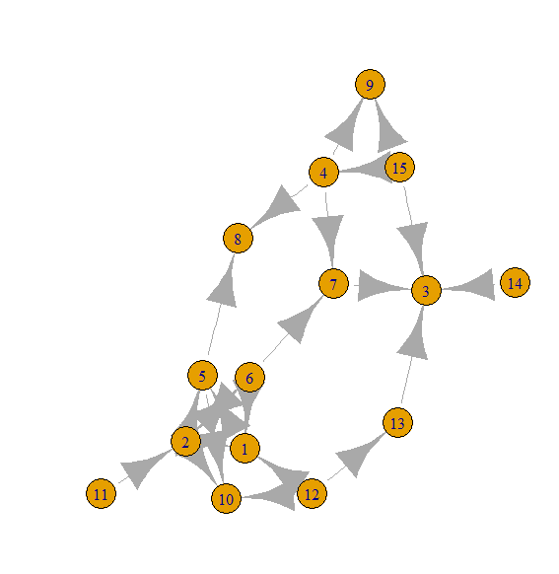

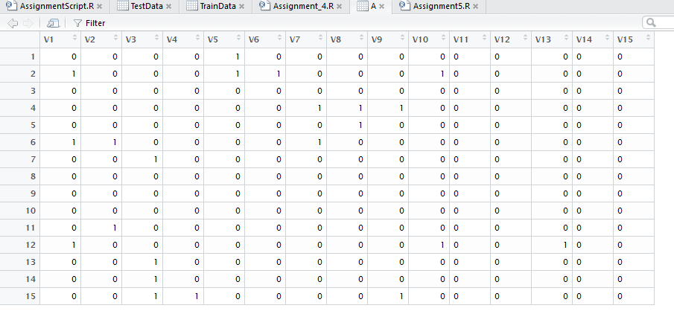

Transpose of Adjacency matrix is below (TAdj)

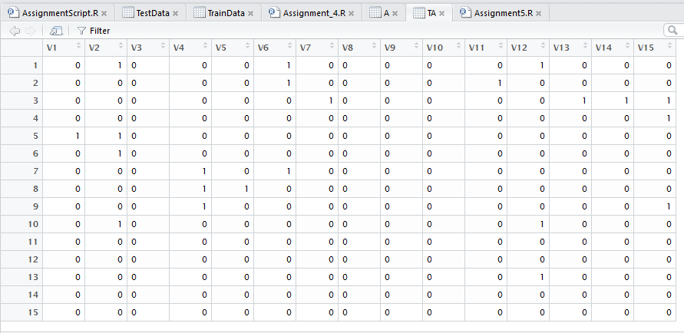

2) Find the Hubs and Authorities of the graphs below given by HITS. Are the results consistent with the notions of Hubs and Authorities?

a) The Adjacency matrix is as below

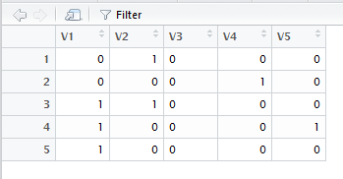

The Graph generated is as below

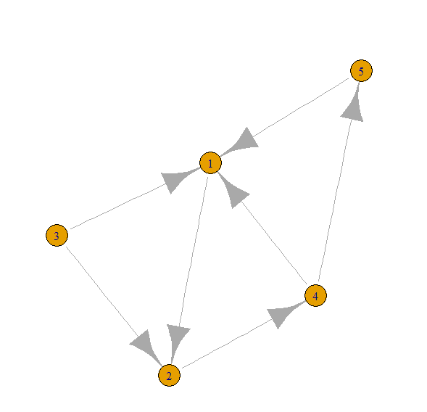

B <-matrix(c(0,1,0,0,0,

+ 0, 0, 0, 1, 0,

+ 1, 1, 0, 0, 0,

+ 1, 0, 0, 0, 1,

+ 1, 0, 0, 0, 0),

+ nrow=5,ncol=5, byrow=TRUE);

Graph2 <-graph.adjacency(B,mode=c("directed"),weighted=NULL);

plot(Graph2)

res2 <- HITS(Graph2,6)

res2[1:5]

Normalized Authority vector is :

[1] 0.8436313066 0.4502423604 0.0000000000 0.0003056635 0.2925199857

res2[6:10]

Normalized Hub vector is :

[1] 0.2285941657 0.0001551895 0.6569172460 0.5768394527 0.4283230803

b) The Adjacency matrix is

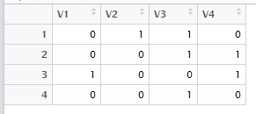

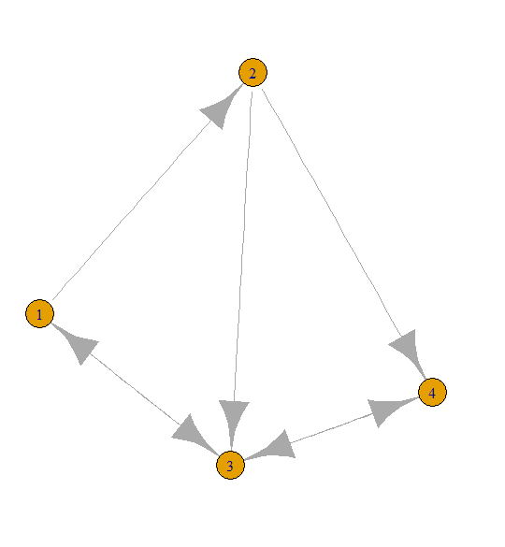

C <-matrix(c(0,1,1,0,

+ 0, 0, 1, 1,

+ 1, 0, 0, 1,

+ 0, 0, 1, 0 ),nrow=4,ncol=4, byrow=TRUE);

> Graph3 <-graph.adjacency(C,mode=c("directed"),weighted=NULL);

> plot(Graph3)

> res3 <- HITS(Graph3,6)

> res3[1:4]

Normalized Authority vector is :

[1] 0.1707698 0.2711439 0.8040635 0.5007999

> res3[5:8]

Normalized Hub vector is :

[1] 0.5405672 0.6560281 0.3376358 0.4042479

Conclusion:

============

For both the graphs the normalized Authority vectors values show that the most informative Authority and link to most informative Authority are found to be for Graph1 and 2 are the nodes 1 and 3 , nodes 3 and 2 respectively that are consistent with the Graphs given.